1. Introduction to NLP
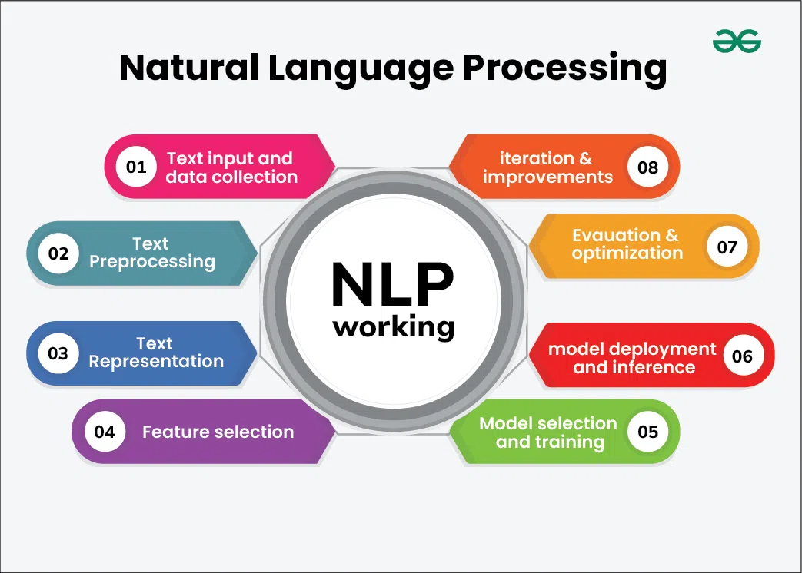
- Definition & Importance
  - What is NLP?
  - History and Evolution
  - NLP vs Computational Linguistics vs Linguistics
  - Applications in the real world
  - Applications of NLP
  - Key challenges
- NLP vs. Traditional Text Processing
- Common NLP Tasks: Tokenization, POS tagging, Parsing, NER, etc.
- NLP Pipeline Overview
- NLP Workflow Overview
  - Data Collection
  - Preprocessing
  - Feature Extraction
  - Model Building
  - Evaluation

2. Python Basics for NLP
- Essential Libraries
  - string, re, collections
  - NumPy, Pandas
  - Matplotlib, Seaborn
- Text File Handling
  - Reading/Writing .txt, .csv, .json
- Regular Expressions
  - Pattern matching
  - Token extraction

—
Setting up the python environment for NLP

3. Text Preprocessing
- Text Cleaning (lowercasing, punctuation, etc.)
  - Normalization
    - Lowercasing
    - Removing punctuation
    - Handling numbers, URLs, emojis
    - Stopwords
- Tokenization
  - Word-level
  - Sentence-level
  - Subword tokenization (BPE, WordPiece)

- Stemming & Lemmatization
  - Porter Stemmer, Snowball Stemmer
  - WordNet Lemmatizer
- Spelling Correction
- Text Cleaning with Libraries
  - nltk, spacy, textblob, clean-text
- Practical: Build a basic text preprocessing pipeline

NLTK is an acronym for Natural Language Toolkit. It is a powerful open-source Python library used for working with human language data, providing tools and resources for natural language processing (NLP).
Developed by Steven Bird and Edward Loper at the University of Pennsylvania, NLTK includes functionalities such as:
- Classification: Grouping text into categories.
- Tokenization: Breaking down text into individual words or sentences.
- Tagging: Labeling words with their part of speech (e.g., noun, verb).
- Stemming and Lemmatization: Reducing words to their base or root form.
- Parsing: Analyzing the grammatical structure of sentences.
spaCy is a free, open-source
Python library for advanced Natural Language Processing (NLP). Built for production, it is known for its speed, efficiency, and deep learning integrations, making it a popular choice for developers and researchers working with large volumes of text.
Key features
- Production-ready: Unlike research-focused libraries like NLTK, spaCy is designed for building real-world applications.
- Efficient: It is implemented in Python and Cython to provide C-like performance.
- Intuitive API: The library features a streamlined and user-friendly interface.
- Pre-trained pipelines: It offers pre-trained statistical models for many languages that enable various NLP tasks out-of-the-box.
- Configurable: spaCy's processing pipeline can be customized with pre-built components or your own functions.
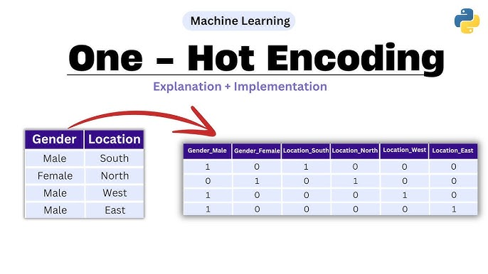

4. Text Representation Techniques/Feature Extractions Techniques
- Bag of Words (BoW) and Vector Space Model
- TF-IDF (Term Frequency–Inverse Document Frequency) Concept, Calculation, and Limitations
- Cosine Similarity
- Word Embeddings
  - Distributional Semantics
  - Word2Vec (CBOW, Skip-gram)
  - GloVe
  - Semantic Similarity
  - FastText
Practical: Use pre-trained word vectors, visualize with t-SNE
- Contextual Embeddings
  - ELMo
  - BERT embeddings
- Sentence & Document Embeddings
  - Universal Sentence Encoder
  - Sentence-BERT
- Practical: Text classification using BoW and TF-IDF (e.g., spam detection)

4.1. Linguistic Features & POS Tagging
Linguistics is the scientific study of language. The areas of linguistic analysis are syntax, semantics, morphology, phonetics, phonology, and pragmatics. Subdisciplines such as biolinguistics and psycholinguistics bridge many of these divisions.
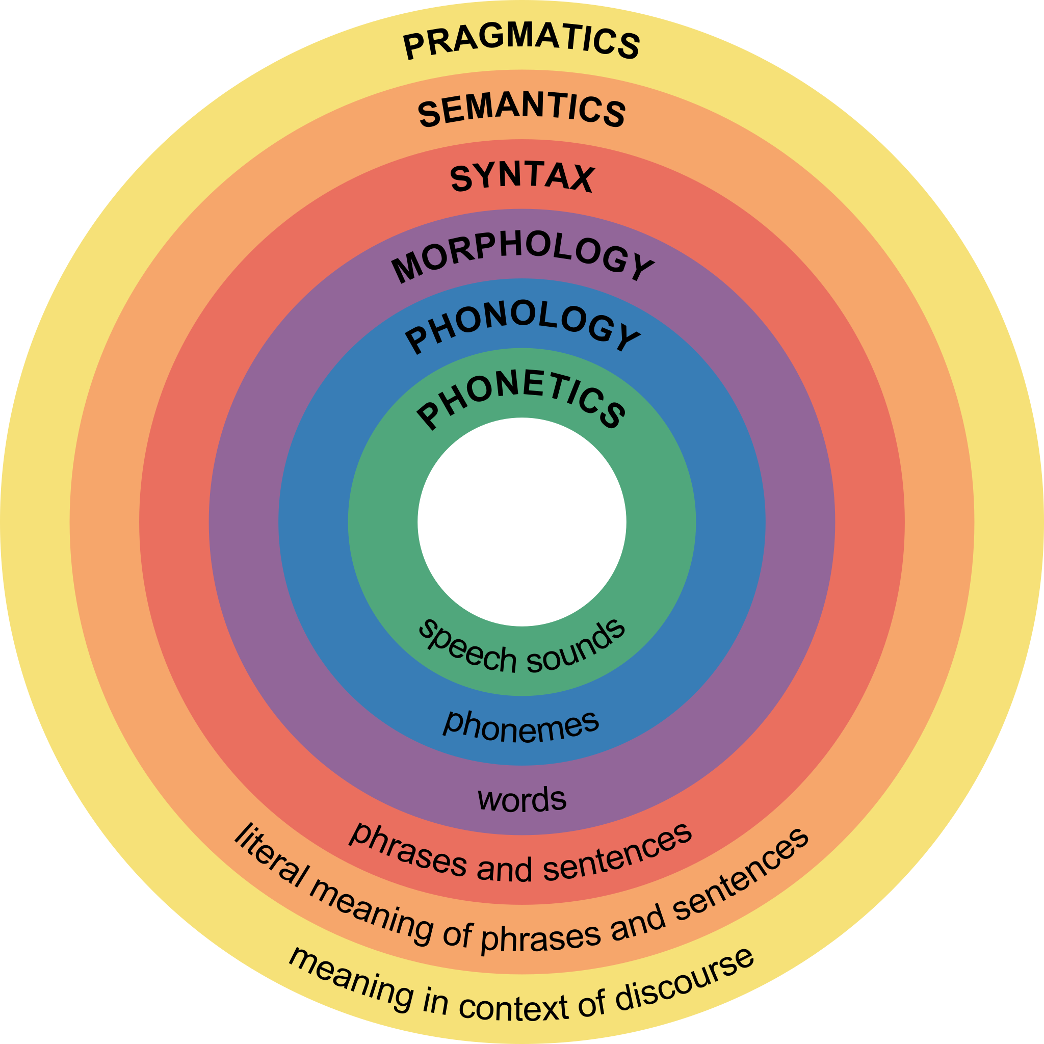
- Parts of Speech tagging
- Syntax trees (constituency and dependency)
- Named Entity Recognition (NER)
- Chunking and Chinking
- Practical: Use NLTK/spaCy for tagging and NER

Language Modeling & N-Grams
- What is a Language Model?
- Its applications
- N-gram models(uni,bi,tri)
- Smoothing Techniques (Laplace, Add-k)
- Evaluation language Modeling with Perplexity
- Practical: Build a trigram language model

Optional → Hidden Markov Model(HMM)
→ Probabilistic Context-free Grammars(PCFGs)

5. NLP with Traditional Machine Learning
- Feature Extraction
  - N-grams
  - POS tagging
  - Named Entity Recognition (NER)
- ML Models for NLP
  - Text Classification Pipeline
  - Naive Bayes(Bayesian methods in nlp)
  - Logistic Regression
  - SVM
  - Decision Trees & Random Forests
- Evaluation Metrics
  - Accuracy, Precision, Recall, F1-score
  - Confusion Matrix
  - Practical: Sentiment analysis on movie reviews or Twitter data

6. Deep Learning for NLP
The term "Artificial Intelligence" (AI) was first used in 1955 by computer scientist John McCarthy. He coined the phrase in a proposal for a summer workshop at Dartmouth College, which is considered the official birth of AI as an academic discipline.
- Neural Network Basics
  - Feed-forward Networks
  - Backpropagation

Sequence Models: RNN, LSTM, GRU
- Challenges with BoW for sequence data
  - Vanilla RNN
  - LSTM (Long Short-Term Memory)
  - GRU (Gated Recurrent Unit)
  - Vanishing gradient problem
  - Practical: Build a sentiment classifier using LSTM (Keras/PyTorch)
- Seq2Seq Architecture
  - Encoder-Decoder
  - Attention Mechanism
- Transformers
  - Self-attention
  - Multi-head attention
  - Transformer encoder-decoder
  - Positional Encoding
  - Practical: Use Hugging Face Transformers for classification
- Pre-trained Transformer Models
  - Transfer Learning in NLP
  - BERT vs GPT
  - Fine-tuning vs Feature Extraction
  - Masked Language Modeling, Next Sentence Prediction
  - BERT, RoBERTa, DistilBERT
  - GPT, T5, BART
  - Practical: Fine-tune BERT for text classification or NER
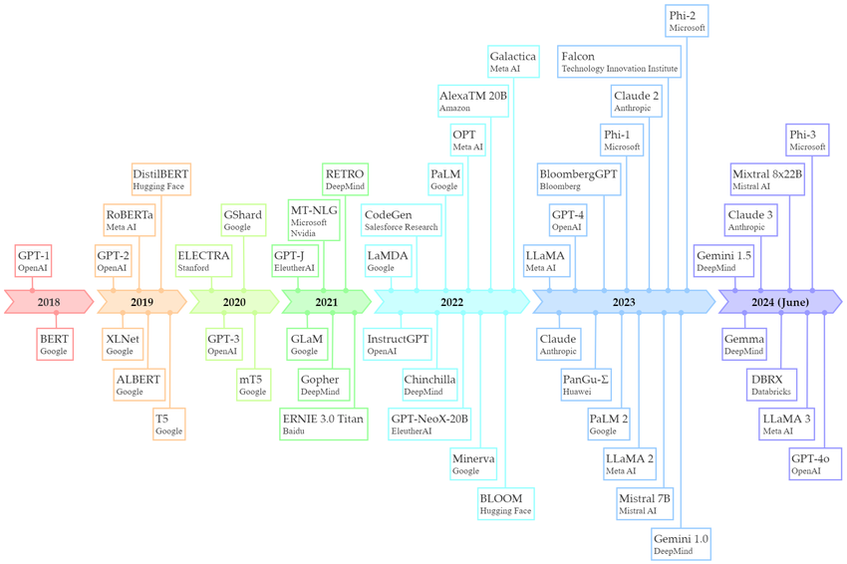

7. NLP Tasks
- Text Classification
  - Sentiment Analysis
    - Rule based sentiment analysis(VADER)
    - ML based Sentiment analysis
  - Spam Detection
  - News Categorization
- Named Entity Recognition (NER)
- Text Summarization
  - Extractive
  - Abstractive
- Text Generation
  - Language Models
  - GPT-based generation
- Question Answering
  - Closed-book
  - Open-domain
- Machine Translation

- Topic Modeling in Probabilistic NLP
  - Latent dirichlet allocation (LDA),
  - Conditional random fields(CRF) for sequence Labeling
  - BERT ,transformers
  - NMF
  - Transfer learning

- Conversational AI
  - Chatbots (Rule-based & AI-based)

Advanced Applications
- Machine Translation
- Text Summarization
- Question Answering
- Chatbots
- Practical: Build a simple QA system using Transformers

Week 12: Project Week + Ethics in NLP
- Final project (choose: classification, chatbot, summarization, etc.)
- Bias and Fairness in NLP
- Ethical considerations (deepfakes, fake news, surveillance)
- Demo Day: Present and critique each other's projects

🧪 Assessments & Projects
- Weekly Quizzes/Assignments
- Midterm Mini Project (e.g., Sentiment Analysis)
- Final Project (end-to-end NLP application)
- Participation in discussions, Kaggle mini challenges (optional)

📚 Suggested Resources
- Book: Speech and Language Processing by Jurafsky & Martin
- Book: Natural Language Processing with Python (Bird et al.)
- Online: Coursera (Deeplearning.ai NLP), Fast.ai, Hugging Face Course
- Papers: “Attention Is All You Need”, “BERT: Pre-training of Deep Bidirectional Transformers”

Would you like this sylla

8. Advanced Topics
- Prompt Engineering for NLP
- Zero-shot and Few-shot Learning
- Fine-tuning Pre-trained Models
  - Hugging Face Transformers
- Multilingual NLP
  - mBERT, XLM-R
- Ethics in NLP
  - Bias, Fairness, Responsible AI
- Large Language Models (LLMs)
  - OpenAI GPT, LLaMA, Mistral

9. Tools & Frameworks
- NLTK
- spaCy
- TextBlob
- Hugging Face Transformers
- Flair
- OpenAI API
- LangChain for NLP Applications

10. Projects
- Beginner
  - Sentiment Analysis on Twitter Data
  - Spam Email Classifier
- Intermediate
  - Named Entity Recognition on News Articles
  - Text Summarization Tool
  - FAQ Chatbot
- Advanced
  - Transformer-based Question Answering
  - Multilingual Machine Translation
  - LLM-powered Document Assistant

11. Deployment
- Deploying NLP Models
  - Flask / FastAPI
  - Streamlit / Gradio apps
- Optimization
  - Model quantization
  - API deployment
- Monitoring & Maintenance

If you want, I can now create a “media-pie style visual syllabus flow” for NLP so that it’s easy to teach step-by-step like a roadmap.
Do you want me to prepare that visual NLP roadmap next?

